**Exercise 9: Implementing the Command Pattern**

**Scenario:** You are developing a home automation system where commands can be issued to turn devices on or off. Use the Command Pattern to achieve this.

**Steps:**

1. **Create a New Java Project:**
   * Create a new Java project named **CommandPatternExample**.
2. **Define Command Interface:**
   * Create an interface Command with a method **execute()**.
3. **Implement Concrete Commands:**
   * Create classes **LightOnCommand**, **LightOffCommand** that implement Command.
4. **Implement Invoker Class:**
   * Create a class **RemoteControl** that holds a reference to a Command and a method to execute the command.
5. **Implement Receiver Class:**
   * Create a class **Light** with methods to turn on and off.
6. **Test the Command Implementation:**
   * Create a test class to demonstrate issuing commands using the **RemoteControl**.

**CODE:-**

// Command Interface

interface Command {

    void execute();

}

// Receiver Class

class Light {

    public void turnOn() {

        System.out.println("Light is ON");

    }

    public void turnOff() {

        System.out.println("Light is OFF");

    }

}

// Concrete Command - Turn On Light

class LightOnCommand implements Command {

    private Light light;

    public LightOnCommand(Light light) {

        this.light = light;

    }

    @Override

    public void execute() {

        light.turnOn();

    }

}

// Concrete Command - Turn Off Light

class LightOffCommand implements Command {

    private Light light;

    public LightOffCommand(Light light) {

        this.light = light;

    }

    @Override

    public void execute() {

        light.turnOff();

    }

}

// Invoker Class

class RemoteControl {

    private Command command;

    public void setCommand(Command command) {

        this.command = command;

    }

    public void pressButton() {

        if (command != null) {

            command.execute();

        } else {

            System.out.println("No command set.");

        }

    }

}

// Test Class

public class CommandPatternExample {

    public static void main(String[] args) {

        Light livingRoomLight = new Light();

        Command lightOn = new LightOnCommand(livingRoomLight);

        Command lightOff = new LightOffCommand(livingRoomLight);

        RemoteControl remote = new RemoteControl();

        System.out.println("Turning ON the light:");

        remote.setCommand(lightOn);

        remote.pressButton();

        System.out.println("Turning OFF the light:");

        remote.setCommand(lightOff);

        remote.pressButton();

    }

}

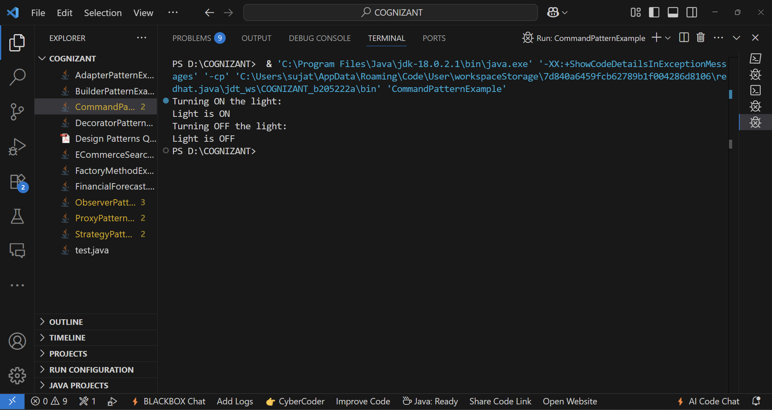**OUTPUT:-**